Welcome to
Revolutions Skating Club
2023-2024 season

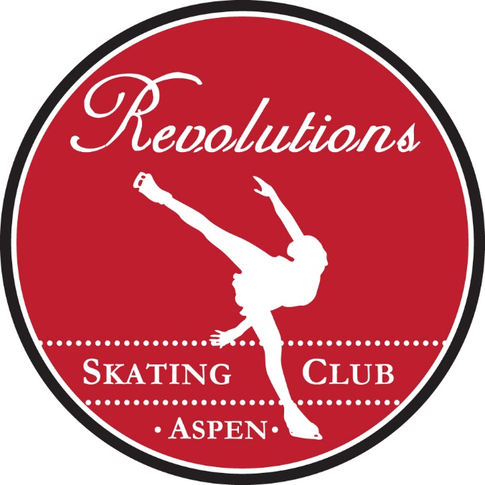

An ice-skating program for all levels and ages;
to promote learning new skills,
increasing self-confidence
making friends and having fun!

www.revolutionssc.com
970-618-6140

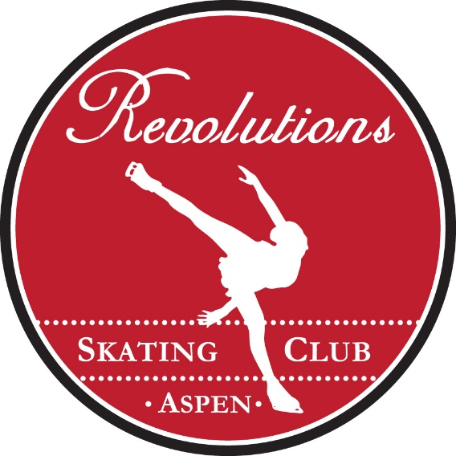

Revolutions Skating Club is a non-profit organization formed to strengthen the figure skating community by providing instruction in all areas of figure skating. As of 2009 we are officially recognized by US Figure Skating as “Revolutions Skating Club”.

Our goal is to provide a creative environment that will foster not only learning and perfecting skills, but also nourish the soul through expression, positive feedback and fun!

RSC Membership: All siblings’ memberships will receive a 25% discount! Please call Michelle Hocknell, 970-618-6140 with any membership questions.

Most importantly, thank you for choosing Revolutions Skating Club
and welcome to the team!

Revolutions Skating Club
Membership
Season: September 2023 – May 2024
RSC Session Choices

Monday 4:00-5:00 (Ice Garden)
- All level skaters are welcome.
- Includes a group class for all skaters, 30 minutes
- $120 per month *This is a monthly invoicing. Invoices will be pro-rated due to ARC closure or sessions cancelled due to scheduling conflicts.
Friday 4:00-5:00 (ARC)
- All level skaters are welcome.
- Includes a group class for all skaters, 30 minutes
- $120 per month *This is a monthly invoicing. Invoices will be pro-rated due to ARC closure or sessions cancelled due to scheduling conflicts.
*Monthly memberships will be prorated when a session is cancelled due to ice scheduling conflicts.
**All siblings’ memberships will receive a 50% monthly discount!

MEMBERSHIP PRICING:
- Each session costs $30 = $120 per month
- Skaters who skate the second day receive that day at a 50% discount
- Siblings receive a 50% discount
- Parents learn and skate for free!
- Skate rental is free of charge
- Memberships are monthly. Skaters may make up a session within the month missed

How do I sign up for Revolutions Skating Club?
- Select your session times from the list above.
- Complete your RSC Membership on-line on our website www.revolutionssc.com, under Membership
- Sign all forms and waivers for Revolutions Skating Club

What will I be invoiced?
- One-time, yearly, USFS membership *Price depends on your skating level
- Monthly skating sessions

How do I pay my invoice?
- Use the “View and Pay Now” button to view your invoice and pay by credit card. This is our preferred method of payment. *Please note that we do not take American Express.

Please feel free to call or email any member of our coaching staff, listed on the following page. Our staff is here to help your skater learn figure skating skills and for parents to learn about Revolutions Skating Club and the sport of figure skating.

*This membership form is also available to complete on our website at www.revolutionssc.com.

RSC Member Application
Skater(s):
Last Name__________________________________ First Name________________________

Last Name__________________________________ First Name________________________

Mother_____________________________________Cell #_____________________________

Father______________________________________Cell#______________________________

Skater(s) Birthdate______________________________________________________________

Mailing Address________________________________________________________________

Best email address_______________________________________________________________

USFS Number__________________________________________________________________

In Case of Emergency, contact:____________________________________________________

Additional notes regarding your athlete (allergies etc.)

______________________________________________________________________________

Sessions Chosen:________________________________________

Participant Signature (if 18 years of age or older)___________________________

Parent or Guardian Signature (if participant is a minor)______________________

Date:____________________

Our Current Coaching Staff:

Grace Hancock (970) 319-4499 ghancock1212@gmail.com

Michelle Hocknell (970) 618-6140 mhocknell@comcast.net

Elaine Kozel (520) 661-9243 kozel460@earthlink.net

All of our coaches are members of the Professional Skaters Association as well as the United States Figure Skating Association.

If you are interested in private or semi-private lessons for your skater(s), please contact the coach directly. Please also feel free to contact any of our coaches with questions regarding lessons, equipment, competitions, etc. Our coaches are here to help YOU!

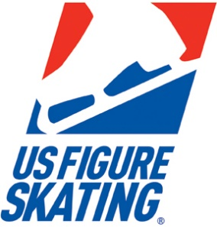

US Figure Skating is the governing body of all figure skating in the United States.

Revolutions Skating Club is proud to be an affiliating member! It is required that all of our skaters register as members of US Figure Skating, in addition to RSC.

Below are the membership categories and prices, which are in addition to the Revolutions Skating Club membership fee:

BASIC SKILLS: This is for all skaters who have not yet tested in the USFS testing system. (If you aren’t sure, you most likely have not tested) $18

INTRODUCTORY: This is for the very first year that a skater begins USFS testing or is preparing to test. This first-year price is $40. Subsequent Introductory $35.

US FIGURE SKATING FULL MEMBERSHIP: For all Revolutions Skating Club members who are entering their second or more year of skating with US Figure Skating in the testing structure. Board members are required to have this membership and any parent may also join US Figure Skating with this membership. First Family Member: $70 Subsequent: $35

COLLEGIATE: This membership covers all (4) years of college for any US Figure Skating member who wishes to remain a member while attending college. $100 for all four years, total.

*The yearly USFS Membership term begins July 1st and ends on June 30th.

SPECIAL EVENTS!

In addition to our every-day fun of skating, Revolutions also offers several opportunities for our skaters to perform. We have low-key exhibitions through-out the season including the “Holiday Performance” and our “Spring Fling”, taking place at the end of the season. Our skaters also perform their programs individually before competitions to experience the competition atmosphere with a supportive, home audience.

AWARDS DINNER
At the end of our season, in May, our skaters and parents come together to celebrate the progress and accomplishments of all of our skaters. We have dinner together and enjoy having the chance to socialize outside of the rink!

Olympic Ice Show
This ice show is an amazing opportunity for ALL of our skaters to skate with Olympic and professional skaters in a top-quality production. It is an event for the whole community and is also a club fund-raising opportunity. There are lots of opportunities to volunteer for parents and friends and it is truly a special experience for all. Please see our website for past show photos.
*This show is budget dependent.

DUCKY DERBY FESTIVAL: AUGUST
Each summer the Aspen Rotary Club holds its annual Ducky Derby Festival. Ducks are adopted (sold) for approximately two months, and the proceeds of the duck sales go directly to the person / organization selling the ducks. 20% of the sales return to the Aspen Rotary Club and 80% of the sales go to the individual skater to be used for figure skating expenses.
Revolutions Skating Club also hosts a booth at the Ducky Derby Festival. We sell snow cones and cotton candy, and everyone is covered in sugar by the end of the day! 100% of the proceeds from our booth go directly to Revolutions Skating Club. Duck sales will begin in June and you may sell paper ducks (in person) or on-line ducks. All skaters are encouraged to participate!

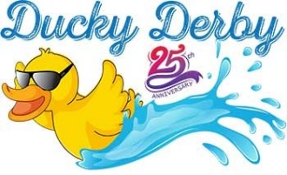
Revolutions Skating Club will host special events throughout the season, allowing all of our skaters to relax, have fun and socialize with each other! We are not just a skating club, but also foster the environment of a skating community.

REVOLUTIONS SKATING CLUB
Waiver of Release of Liability, Assumption of Risk and Indemnity Agreement (“Agreement”)

In consideration of participating in Revolutions Skating Club activities, I represent that I understand the nature of figure skating activities (“activity”) and that I am qualified, in good health and in proper physical condition to participate in such “activity”. I acknowledge that if I believe event conditions are unsafe I will immediately discontinue participation in the “activity”.

I fully understand that this “activity” involves risks of serious bodily injury, including permanent disability, paralysis and death, which may be caused by my own actions, or inactions, those of others participating in the “activity”, the conditions in which the “activity” takes place, or the negligence of the “releasees” named below; and that there may be other risks either not known to me or not readily foreseeable at this time; and I fully accept and assume all such risks and all responsibility for losses, costs and damages I incur as a result of my participation in the “activity”.

I hereby release, discharge, and covenant not to sue the Revolutions Skating Club, United States Figure Skating, it’s directors, officers administrators, sponsors, volunteers, agents, employees, staff, instructors, trainers, other participants and if applicable, owners and lessors of premises on which the “activity” takes place (each considered one of the “Releases” herein) from all liability, claims, demands, losses, or damages on my account caused or alleged to be caused in whole or in part by the negligence of the “releasees” or otherwise, including negligent rescue operations; and I further agree that if, despite this release, waiver of liability, and assumption of risk, I, or anyone on my behalf, makes a claim against any of the Releasees, I will indemnify, save, and hold harmless each of the releasees from any loss, liability , damage, or cost which any may incur as the result of such claim.

The Revolutions Skating Club has the right, but not the obligation, to provide rules, regulations and/or ice monitors for Club ice. We hereby acknowledge that the Revolutions Skating Club shall not be responsible for the supervision of the members at Club ice.

I have read this RELEASE AND WAIVER OF LIABILITY, ASSUMPTION OF RISK, AND INDEMNITY AGREEMENT, understand that I have given up substantial rights by signing it and have signed it freely and without any inducement or assurance of any nature and intend it to be a complete and unconditional release of all liability to the greatest extent allowed by law and agree that if any portion of this agreement is held to be invalid, the balance, not withstanding, shall continue in full force effect.

______________________________________________ ______________________________________
Printed Name of Participant Date

_____________________________________________________________________________________
Signature of Participant or Guardian if under the age of 18

PARENTAL CONSENT AND INDEMNIFICATION
AGREEMENT

I, the minor’s parent and/or legal guardian, understand the nature of this activity and the minor’s experience and capabilities and believe the minor to be qualified to participate in such activity. I hereby release, discharge, covenant not to sue and agree to indemnify and save and hold harmless each of the Releasees from all liability, claims, demands, losses or damages on the minor’s account caused or alleged to have been caused in whole or in part o by the negligence of the Releasees or otherwise, including negligent rescue operations, and further agree that if, despite this release, I, the minor, or anyone on the minor’s behalf makes a claim against any of the Releasees, I will not indemnify, save and hold harmless each of the Releasees from any litigation expenses, attorney fees, loss liability, damage, or cost any Releasees may incur as the result of any such claim.

____________________________________________ _________________________________
Printed Name of Parent/Guardian Date

____________________________________________
Signature of Parent / Guardian

Consent for Medical Attention or Treatment:

I certify that I, the member, or I, the parent/guardian of said participant, give my consent to the Revolutions Skating Club instructors, their Board of Directors and volunteers, to obtain medical care from any licensed physician, hospital, or clinic, including transportation and emergency medical services, for said participant for any injury that could arise from participation in this activity.

_________________________________________ ____________________________________
1st Minor Member 2nd Minor Member

_________________________________________ ___________________________________
Adult member or Parent / Guardian of minor Date
Member, signature

*This Consent for Medical Attention shall be binding and effective for the 2021-2022 membership year of Revolutions Skating Club.

REVOLUTIONS SKATING CLUB
MEMBER CHECKLIST

- RSC on-line application completed and signed
- Your email address has been provided to RSC for weekly, email communications
- Skater understands to sign in for every session
- Both skater and parents agree to comply with the Covid-19 guidelines, if necessary
- Any membership package changes must be received in writing prior to the month the day/change will be taking place
- I have read the following on www.revolutionssc.com: USFS Skater Code of Conduct, USFS SafeSport Handbook, USFS SafeSport Reporting Process

IMPORTANT:
Per the rules and regulations provided by US Figure Skating, all the above must be completed before a skater can receive their membership with Revolutions Skating Club. Skaters may skate (1) trial session but will not be able to continue to skate unless the above is completed.

I have read the membership packet completely and have complied with the Revolutions Member Checklist, shown above.

______________________________________ ____________________________
Parent / Guardian / Adult Skater Date

Thank you for choosing Revolutions Skating Club.
We are looking forward to a great season!

