***REVOLUTIONS SKATING CLUB JACKETS AND PANTS!***

***FLEECE LINED, WARM, TOASTY AND RHINESTONES!***

* Elite Polartec Fleece Jacket
* Thumb Holes
* 49% Poly 38% Nylon 13% Spandex
* Made in USA
* Rhinestones included
* Sizes: CXS, CS, CM, CL, CXL/AXS, AS, AM, AL
* Revolutions Logo on the back
* First name on the front
* $135.00
* 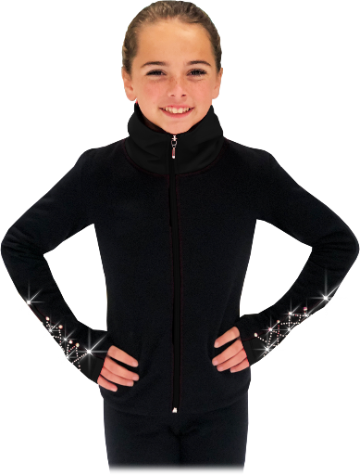

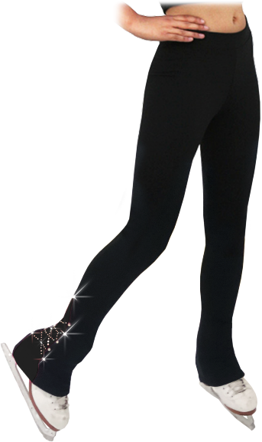

* Elite Polartec Fleece Pants
* 49% Poly 38% Nylon 13% Spandex
* Waistband elastic width: 1”
* Made in USA
* Rhinestones included
* Sizes: CXS, CS, CM, CL, CXL/AXS, AS, AM, AL
* $95.00

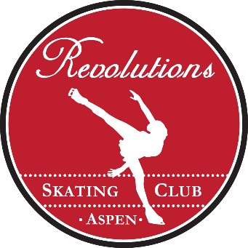

SKATER’S FIRST NAME_________________________________________________

LAST NAME__________________________________________________________

JACKET SIZE:______________________ PANT SIZE________________________

NAME TO BE PRINTED ON JACKET FRONT:__________________________________________

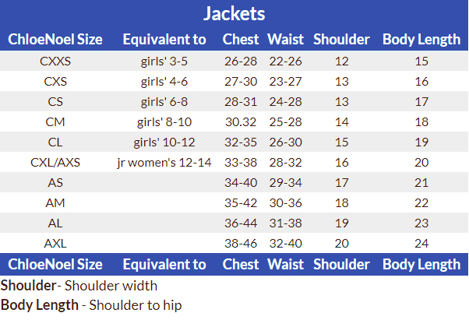

The pants tend to run a bit long.